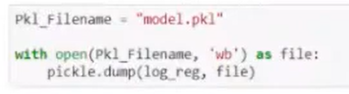

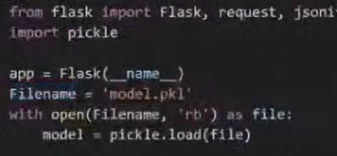

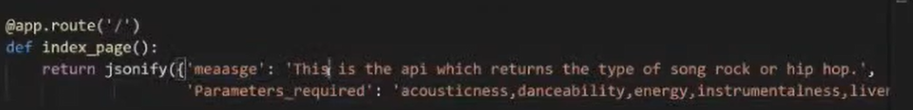

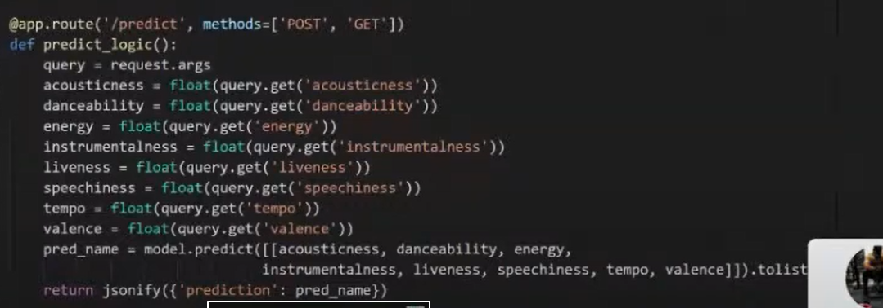



@app.route(‘/predict’, methods=[‘POST’,’GET’])

def predict_lofic():

query = request.args

campo1 = float(query.get(‘campo1’))

resultado = modelo.predict([adf, adfd, adfd

return jsonify({‘prediction’: resultado})

https://www.youtube.com/watch?v=MAu1fPqlivk

from flask import Flask

app = Flask(_name_)

@app.route("/")

def hello():

return("This is SPARTA!!")

@app.route("/page1")

def hello():

return("This is Page 1")

app.run()

import pickle

filename = 'model.sav'

pickle.dump(model, open(filename, 'wb'))

load_model = pikle.load(open(filename,'rb'))

r= load_model.score(text_X, test_y)

r